SAN ANGELO INDEPENDENT SCHOOL DISTRICT

GENERAL CONDITIONS FOR BIDDING

- Bids shall be submitted on this form. All prices must be typed or written in ink. Bids written in pencil will not be accepted. Each bid shall be placed in a separate envelope, sealed and properly identified with the bid title and the time and date to be opened.

- Bids must be received in the Purchasing Department office before the hour and date specified. DO NOT FAX YOUR BID!

- Prices bid should be F.O.B. destination, inside delivery. All freight charges must be included in your bid pricing. If otherwise, state on Deviation/Compliance Signature form.

- Delivery shall be made during normal school hours unless prior approval has been obtained from authorized District personnel.

- All items bid must be new, unused, and in first-class condition, packaged in containers suitable for shipment and storage. If otherwise, state on Deviation/Compliance Signature form.

All electrical items must meet all applicable OSHA standards and regulations, and must bear the appropriate listing from US, FMRC, NEMA, or U L Laboratories.

Materials Safety Data Sheets (MSDS) on chemicals or any other products customarily requiring MSDS Sheets must be provided for each ordering department. MSDS Sheets must be delivered along with the shipment within the contract period. Additional MSDS Sheets must be provided in a timely manner at no charge upon request to the District.

- Installation: the successful bidder shall provide the following services on the items bid, at no additional cost to the District, if otherwise, state on Deviation/Compliance Signature form.

- Provide transportation of items to the facility.
- Place the items in the proper location within the facility.
- Uncrate and completely assemble (if otherwise, state on Deviation/Compliance Signature form).
- Provide adjustment by a trained installation mechanic.
- Remove all debris from site.

- The District is exempt from Federal Excise Tax, and State Tax. Do not include tax in your bid totals. If it is determined that tax was included in the bid, it will not be included in the tabulation or any awards. Tax exemption certificate will be furnished upon request.

- Any catalog, brand name, or manufacturer’s reference used in the bid is descriptive and not restrictive and is intended to indicate type and quality desired. Bids on brands of like nature and quality will be considered. If bidding on other than referenced specifications, bid must show manufacturer, brand, model, etc. of item being offered. If other than brand(s) specified is offered, complete descriptive information of each article being bid should be included with the bid. If bidder takes no exception to the specification of referenced data, he will be required to furnish brand names, models, etc. as specified.

- Samples, when requested, must be furnished at no cost to the District. Each sample, when requested, should be clearly marked with bidder’s name and item number on the bid. DO NOT ENCLOSE IN OR ATTACH BID TO SAMPLE.

- The Board of Trustees of San Angelo Independent School District reserves the right to accept or reject all or any part of any bid, waive minor technicalities and award the bid to best serve the interest of the District.

- The District reserves the right to purchase or lease-purchase additional articles as listed on this bid subject to verification of the same or lower prices and conditions on bid.

- All items and services being bid must conform to all appropriate local, state, and federal laws, ordinances, and regulations.

- It is to be understood that the bidder, if awarded an order or contract, agrees to protect, defend, and hold harmless the San Angelo Independent School District from any suits or demands for payment that may be brought against it for the use of any patented material, process, article, or device that may enter into the manufacture and/or construction or from a part of the work covered by either order or contract and, bidder further agrees to indemnify and hold harmless the San Angelo Independent School District from suits or actions of every nature and description brought against it for, or on account of any injuries or damages received or sustained by any party or parties by, or for any of the acts of the vendor, his servants or agents.

- It is not the policy of the District to purchase on the basis of low bids alone. In evaluating bids submitted and per the Texas Education Code 44.031(b), the following considerations shall be taken into account to determine the best value for the District.

    - the purchase price;
    - the reputation of the vendor and of the vendor’s goods or services;
    - the quality of the vendor’s goods or services;
    - the extent to which the goods or services meet the district’s needs;
    - the vendor’s past relationship with the district;
    - the impact on the ability of the district to comply with laws and rules relating to historically underutilized businesses;
    - the total long-term cost to the district to acquire the vendor’s goods or services;
    - for a contract for goods and services, other than goods and services related to telecommunications and information services, building construction and maintenance, or instructional materials, whether the vendor or the vendor’s ultimate parent company or majority owner: (a) has its principal place of business in this state; or (b) employs at least 500 persons in this state; and
    - any other relevant factor specifically listed in the request for bids and proposals.

15. The contract will be awarded in the best interest of San Angelo Independent School District. Specific award information is located under Specific Terms and Conditions Item #1.

16. Any and all protests regarding San Angelo ISD bidding procedures will be governed by the San Angelo Independent School District Board Policy for Grievances.

17. If the District fails to appropriate funds to provide for the annual renewal of a contract, the District may cancel without termination charge. This is provided that the Contractor receives at least 30 days written notice of the termination stating the lack of funding as the reason for the termination.

- The San Angelo Independent School District may not be held liable for non-funding of a contract caused through no fault of its own.

- Vendors not responding appropriately to Bid Requests will be deleted from our qualified vendor list and will not be reinstated unless specifically requested. SAISD reserves the right to delete vendors that do not respond appropriately.

- All Bidders must execute the “Affidavit of Non-Collusion”, “Felony Conviction Notification”, “Bidders Certification”, “Debarment and Suspension Certification Form”, “Deviation/Compliance Signature Form”, or “No Bid Notification” enclosed herewith for his bid to be considered. The name of the company representative on these forms should be the same.

- Bid results will be presented to the San Angelo Independent School District Board of Trustees for approval at the earliest opportunity following the bid/proposal opening if $25,000 or greater.

- It is the policy of the San Angelo Independent School District not to discriminate on the basis of sex, disability, race, color, or national origin in its educational programs and/or activities, nor in its employment practices.

- The bidder shall not sell, assign, transfer, or convey any contract resulting from this proposal, in whole or part, without the prior written consent from the District. Such consent shall not relieve the assigned of liability in the event of default by the assignee.
STANDARD TERMS AND CONDITIONS

- CERTIFICATION: By signature on Bid Document the vendor certifies that:

- The vendor has not paid, or agreed to pay, any person, other than bona fide employees, a fee or brokerage resulting from the award of any contract resultant from this bid.
- The prices in this bid have been arrived at independently without consultation, communication, or agreement, for the purpose of restricting competition as to any matter relating to such prices, with any other vendor or potential vendor.

- CONTRACT MODIFICATION: No modification of this contract shall bind buyer unless a formal contract amendment is executed between buyer and vendor.

- CONTRACT AND PURCHASE ORDERS: A response to this Bid Document is an offer to contract with the SAISD and its members based upon the Item Specifications and the Standard Terms and Conditions contained in the Bid Document. Bids do not become contracts unless and until they are accepted by the SAISD and put into effect by the issuance of a Purchase Order(s) signed by an authorized representative of the SAISD Purchasing Department.

This contract shall collectively include (1) the General Terms and Conditions and the Item Specifications included in the Bid Document and any subsequent addenda thereto, (2) the bidder’s signed Notice of Bid Document sheet and any other data collection sheets included with the Bid Invitation, (3) the bidder’s entire response to the Bid Invitation, (4) the bidder’s Notice of Award Letter, (5) and any additional terms, conditions, or instructions contained in each individual Purchase Order. The contract shall be interpreted by and governed under the law of the State of Texas in Tom Green County.

4. PACKING AND SHIPPING: (If applicable) vendor shall be responsible for industry standard packing which conforms to requirements of carrier’s tariffs and ICC regulations. Containers must be clearly marked as to the purchase order number. All shipments are to be F.O.B. destination, freight prepaid, to San Angelo Independent School District at the specific address on the purchase order. Delivery shall be made during normal working hours only, 8:00am to 3:00pm, unless approval for late delivery has been obtained.

5. NO REPLACEMENT OF DEFECTIVE TENDER: (If applicable) every tender of goods must fully comply with all the provisions of this contract as to time of delivery, quantity, assortment, quality, and the like. If a tender is made which does not fully conform, this shall constitute a breach and vendor shall not have the right to substitute a conforming tender.

6. DEFAULT IN ONE INSTALLMENT TO CONSTITUTE TOTAL BREACH: (If applicable) each installment or lot of this contract is dependent on every other installment or lot and delivery of non-conforming goods/services or a default of any nature under one installment or lot will impair the value of the whole contract and constitutes a breach of the contract as a whole.

- GRATUITIES: The buyer may, by written notice to the vendor, cancel this contract if it is found by buyer that gratuities, in the form of entertainment, gifts or otherwise were offered or given by the vendor or any agent or representative of the vendor, to any employee of the San Angelo Independent School District with a view toward securing an order or securing favorable treatment with respect to the awarding or amending, or the making of any determinations with respect to the performing of such order. In the event this contract is canceled by buyer pursuant to this provision, buyer shall be entitled, in addition to any other rights and remedies, to recover or withhold from the vendor the amount of the gratuity.

- WARRANTIES: (If applicable) vendor warrants that all goods delivered under this contract will conform to the requirements of this contract (including all applicable descriptions, specifications, drawings, and samples), and will be free from defects in design and fit for the intended purposes. Any inspection or acceptance of the goods by buyer shall not alter or affect the obligations of vendor or the right of buyer under the foregoing warranties.

- ASSIGNMENT-DELEGATION: No right or interest in this contract shall be assigned by vendor without the written permission of buyer, and no delegation of any duty of vendor shall be made without permission of buyer. Any attempted assignment of delegation shall be wholly void and totally ineffective for purposes unless made in conformity with this paragraph.

- ASSIGNMENT-CLAIMS: Vendor and the San Angelo Independent School District recognize that in actual economic practice overcharges resulting from anti-trust violations are in fact borne by the District. Therefore, vendor hereby assigns the District any and all claims for such overcharges.

- ADVERTISING: Vendor shall not advertise or publish, without the District’s prior consent, the fact that the District has entered into this contract, except to the extent necessary to comply with proper requests for information as provided by appropriate statues.

- TITLE AND RISK OF LOSS: (If applicable) the title and risk of loss of the goods shall not pass to the District until the District actually receives the goods at the point of delivery.

- INSPECTION: (If applicable) all goods are subject to final inspection and acceptance by the District. Material/services failing to meet the requirements of this contract will be held at vendor’s risk and may be returned to vendor. If so returned, the cost of transportation, unpacking, inspection, repackaging, reshipping, or other like expenses are the responsibility of the vendor.

- LIENS: All goods delivered and labor performed under this contract shall be free of all liens, and if the District requests, a formal release of all liens will be delivered to the District.

- INDEMNIFY: Vendor agrees to indemnify and hold the District harmless from any damage or expense whatsoever resulting to the District from any and all claims and demands on account of infringement or alleged infringement of any patent in connection with the manufacture of use of any product included in this contract. Upon written requests vendor will defend, at it’s own cost and expense, any legal action or suit against the District involving any such alleged patent infringement, and will pay and satisfy any and all judgements or decrees rendered in any such legal actions or suits. Vendor will indemnify San Angelo Independent School District against all claims for damages to persons or property resulting from defects in materials or workmanship.

- REMEDIES AND APPLICABLE LAWS: This contract shall be governed by San Angelo Independent School District and vendor shall have all remedies afforded each by the Uniform Commercial Code, as adopted in the State of Texas, except as otherwise provided in this contract or in statutes pertaining specifically to the State. This contract shall be governed by the laws of the State of Texas, and suits pertaining to this contract may be brought only in the courts of the State of Texas in Tom Green County.

- CONFLICT OF INTEREST: This contract is subject to cancellation by buyer if any person significantly involved in initiating, negotiating, securing, drafting or creating the contract on behalf of San Angelo Independent School District, is at any time while the contract is in effect, an employee of any other party to the contract in any capacity or a consultant to any other party of the contract with respect to the subject matter of the contract.

- FORCE MAJEURE: Neither party shall be held responsible for any losses resulting if the fulfillment of any terms or conditions of this contract are delayed or prevented by any other cause not within the control of the party whose performance is interfered with and which, by the exercise of reasonable diligence, said party is unable to prevent.

- RIGHT TO ASSURANCE: Whenever one party to this contract in good faith has reason to question the other party’s intent to perform, he may demand that the other party give a written assurance of this intent to perform. In the event that demand is made and no assurance is given within five (5) days, the demanding party may treat this failure as an anticipatory repudiation of the contract.

- INTERPRETATION-PAROL EVIDENCE: This contract is intended by the parties as a final expression of their agreement and is intended also as a complete and exclusive statement of the terms of this agreement. No course of prior dealing between the parties and no usage of the trade shall be relevant to supplement or explain any term used in this contract. Acceptance or acquiescence in a course of performance rendered under this contract shall not be relevant to determine the meaning of this contract even though the accepting or acquiescing party has knowledge of the nature of the performance and opportunity to objection. Whenever a term defined by the Uniform Commercial Code is used in this contract, the definition contained in the Code is to control.

- COMPLIANCE OF LAWS: The final contract must be in compliance with all federal and Texas State laws and regulations and is subject to termination by the Governing Board of the San Angelo Independent School District, termination for non-availability of funding and for prepayment, without penalty.

- CHOICE OF LAW: The parties hereby agree that this agreement was negotiated, made and entered into in the State of Texas and under the laws of the State of Texas.

- INFRINGEMENT: Contractor agrees to protect San Angelo Independent School District from claims involving infringement or copyrights.

- TECHNICAL SPECIFICATIONS: Technical specifications define the minimum acceptable standard.

- REMEDIES FOR NON-PERFORMANCE OF CONTRACT, AND TERMINATION OF CONTRACT: If the vendor cannot comply with the terms and conditions in fulfilling its contract as anticipated, the vendor must supply the same products or services contracted from other sources at the contract price. The vendor’s delay in the above will constitute the vendor’s material breach of contract, whereupon the SAISD may terminate the vendor’s contract for cause as provided by the remainder of this section.

If any delay or failure of performance is caused by a Force Majeure event as described in section #18 of this Standard Terms and Conditions document entitled “Force Majeure,” the SAISD may, in its sole discretion, terminate this contract in whole or part, provided such termination follows the remaining requirements of this section.

Except as otherwise provided for within the Standard Terms and Conditions of this document, this contract may be terminated in whole or in part by either party in the event of substantial failure by the other party to fulfill its obligations under this contract through no fault of the terminating party; provided that no such termination may be implemented unless and until the other party is given (1) at least ten (10) days written notice (delivered by certified mail, return receipt requested) of intent to terminate, and (2) an opportunity for consultation with the terminating party, followed by a reasonable opportunity, of not more than ten (10) working days, to rectify the defects in products or performance, prior to termination.

Valid causes for termination of this contract will include, but are not limited to:

- The vendor’s failure to adhere to any of the provisions of the General Conditions and Standard Terms and Conditions of the Bid Document.
- The vendor delivering any product(s) that fails to meet the Item Specifications included in this Bid Invitation relating to the awarded product(s).
- The vendor delivering any substitution(s) of product(s) different than those originally bid and awarded without the written approval of SAISD.
- The vendor’s incomplete response to the Bid Document.
- And vendor’s noncompliance to any additional terms, conditions, or instructions contained in each individual Purchase Order issued by the SAISD.

- ORDER OF PRECEDENCE: In the event of conflict, the following precedence shall prevail: 1) terms and conditions set forth on the face of the contract, 2) provisions set forth on specifications, 3) provisions set forth in Referenced Documents; and 4) the general bidding instructions to bidders.

- ERRORS OR OMISSIONS: The District is not responsible for any bidder’s errors or omissions.

- CONFIDENTIAL INFORMATION: If a vendor believes that a bid, proposal, offer, or specification contains information that shall be withheld from disclosure, a statement advising the procurement officer must be attached and noted on page one of the document.

- ADDENDUM: In the event that any changes to this Bid Document occur subsequent to the mailing or other delivery of the original Bid Document, the changes or corrections to this Bid Invitation will be made by addendum. It is your responsibility to obtain any addenda that pertains to this bid. We are no longer mailing the specifications or addenda.

- EXTENSION/NON-APPROPRIATIONS CLAUSE: This contract may be renewed for two additional one year terms if the vendor and the District agree.

- Price increases for additional year will be negotiated not to exceed the CPI in the San Angelo area at the time of renewal. Price negotiations may be negotiated to prices below the current pricing.

- Negotiations for additional years and price restructuring must be completed forty-five (45) days before date of renewal.

33. INSURANCE REQUIREMENTS - PROOF OF INSURANCE WILL BE REQUIRED FOR GENERAL LIABILITY, AUTOMOBILE LIABILITY, AND WORKERS’ COMP. INSURANCE LIMITS WILL BE $1,000,000 PER OCCURRENCE ON GENERAL LIABILITY, $500,000 ON AUTO, AND STATUTORY LIMITS ON WORKERS’ COMP. THESE REQUIREMENTS APPLY TO ALL CATEGORIES WHERE SERVICES ARE PROVIDED ON A SAN ANGELO ISD SITE.

CONSTRUCTION BOND REQUIREMENTS - BONDING SURETIES MUST BE QUALIFIED TO DO BUSINESS IN TEXAS AND ACCEPTABLE TO THE DISTRICT.

BID BOND IN THE AMOUNT OF FIVE PERCENT (5%) OF THE BID MUST BE SUBMITTED WITH ANY CONSTRUCTION BID.
PAYMENT BONDS WILL BE REQUIRED IF THE CONTRACT FOR SERVICES EXCEEDS $25,000.00.
PERFORMANCE BONDS WILL BE REQUIRED IF THE CONTRACT FOR SERVICES EXCEEDS $100,000.00.

FORM A

NON-COLLUSION STATEMENT

The undersigned Proposer, by signing and executing this proposal, certifies and represents to the San Angelo Independent School District that Proposer has not offered, conferred or agreed to confer any pecuniary benefit, as defined by Section 1.07 (a)(6) of the Texas Penal Code, or any other thing of value, as consideration for the receipt of information or any special treatment or advantage relating to this proposal;

the Proposer also certifies and represents that Proposer has not offered, conferred or agreed to confer any pecuniary benefit or other things of value as consideration for the recipient's decision, opinion, recommendation, vote or other exercise of discretion concerning this proposal;

the Proposer certifies and represents that Proposer has neither coerced nor attempted to influence the exercise of discretion by any officer, trustee, agent or employee of the San Angelo Independent School District concerning this proposal on the basis of any consideration not authorized by law;

the Proposer also certifies and represents that Proposer has not received any information not available to other proposers so as to give the undersigned an advantage with respect to this proposal;

the Proposer further certifies and represents that Proposer has not violated any state, federal or local law, regulation or ordinance relating to bribery, improper influence, collusion or the like and that Proposer will not in the future, offer, confer, or agree to confer any pecuniary benefit or other thing of value of any officer, trustee, agent or employee of the San Angelo Independent School District in return for the person having exercised the person's official discretion, power or duty with respect to this proposal;

the Proposer certifies and represents that it has not now and will not in the future offer, confer, or agree to confer a pecuniary benefit or other thing of value to any office, trustee, agent or employee of the San Angelo Independent School District in connection with information regarding this proposal, the submission of this proposal, the award of this proposal or the performance, delivery or sale pursuant to this proposal;

the Proposer certifies that the Proposer has not prepared this proposal and will not prepare any future proposals arising from this Request for Proposal (RFP) in collusion with any other respondent, and that the content of any future proposals arising out of this RFP will not be communicated by the undersigned nor by any employee or agent to any other person engaged in this type of business prior to the District’s selection of a contractor for this RFP.

FIRM NAME

ADDRESS

CITY/STATE/ZIP

TYPED NAME OF REPRESENTATIVE(S)

SIGNATURE OF REPRESENTATIVE(S)

DATE

FORM B

FELONY CONVICTION NOTIFICATION

State of Texas Legislative Senate Bill No. 1, Section 44.034, Notification of Criminal History, Subsection (a), states, “a person or business entity that enters into a contract with a school district must give advance notice to the District if the person or owner or operator of the business entity has been convicted of a felony.” The notice must include a general description of the conduct resulting in the conviction of a felony.

Subsection (b) states, “a school district may terminate a contract with a person or business entity if the district determines that the person or business entity failed to give notice as required by Subsection (a) or misrepresented the conduct resulting in the conviction.” The district must compensate the person or business entity for services performed before the termination of the contract.

This notice is not required of a publicly-held corporation.
Please complete the information below:

I, the undersigned agent for the firm named below, certify that the information concerning notification of felony convictions has been reviewed by me and the following information furnished is true to the best of my knowledge.

Vendor’s Name:

Authorized Company Official’s Name (please print or type):

- My firm is a publicly-held corporation; therefore, this reporting requirement is not applicable:

Signature of Company Official: Date:

- My firm is not owned nor operated by anyone who has been convicted of a felony.

Signature of Company Official: Date:

- My firm is owned or operated by the following individual(s) who has/have been convicted of a felony:

Name of Felon(s):

Details of Conviction(s):

Signature of Company Official: Date:

Contractor is responsible for the performance of the persons, employees and/or subcontractors Contractor assigns to provide services for the San Angelo ISD pursuant to this Contract on any and all San Angelo ISD campuses or facilities. Contractor will not assign individuals to provide services at a San Angelo ISD campus or facility who have a history of violent, unacceptable, or grossly negligent behavior or who have a felony conviction, without the prior written consent of the San Angelo ISD Purchasing Department. Prior to supplying labor services under this Contract, Contractor shall provide a list identifying the individuals, employees and subcontractors that may be assigned to San Angelo ISD along with a letter signed by an appropriate officer of Contractor that affirms compliance with this provision. Contractor will revise such letter each time there is a change in Contractor's personnel assigned to a San Angelo ISD campus or facility, but in any case, annually on the anniversary date of this Contract, if applicable.
FORM C

BIDDER’S CERTIFICATION

The 1985 Texas Legislature passed HB 620 relating to bids by nonresident contractors. The pertinent portion of the Act has been extracted and is as follows:

Section 1. (a)

- “Nonresident bidder” means a bidder whose principal place of business is not in this state, but excludes a contractor whose ultimate parent company or majority owner has its principal place of business in this state.

- “Texas resident bidder” means a bidder whose principal place of business is in this state, and includes a contractor whose ultimate parent company or majority owner has its principal place of business in this state.

Section 1. (b) The state or a governmental agency of the state may not award a contract for general construction, improvements, services, or public works projects or purchases of supplies, materials, or equipment to a nonresident bidder unless the nonresident’s bid is lower than the lowest bid submitted by a responsible Texas resident bidder by the same amount that a Texas resident bidder would be required to underbid a nonresident bidder to obtain a comparable contract in the state in which the nonresident’s principal place of business is located.

I certify that is a
(Company Name)

Resident Bidder of Texas as defined in HB 620.

Signature

Print Name

I certify that is a
(Company Name)

Nonresident Bidder of Texas as defined in HB 620 and our principal place of business is:

(City and State)

Signature

Print Name

FORM D

DEBARMENT OR SUSPENSION CERTIFICATION FORM

Non-Federal entities are prohibited from contracting with or making sub-awards under covered transaction to parties that are suspended or debarred or whose principals are suspended or debarred. Covered transactions include procurement of goods or services equal to or in excess of $100,000. Contractors receiving individual awards of $100,000 or more and all sub-recipients must certify that the organizations and its principals are not suspended or debarred.
By submitting this offer and signing this certificate, this bidder:

- Certifies that no suspension or debarment is in place, which would preclude receiving a federally funded contract under the Federal OMB, A-102, Common Rule (§_.36).

Vendor Name:

Vendor Address:

Vendor Telephone:

Authorized Company Official’s Name:
(printed)

Signature of Company Official:

Date:

FORM E 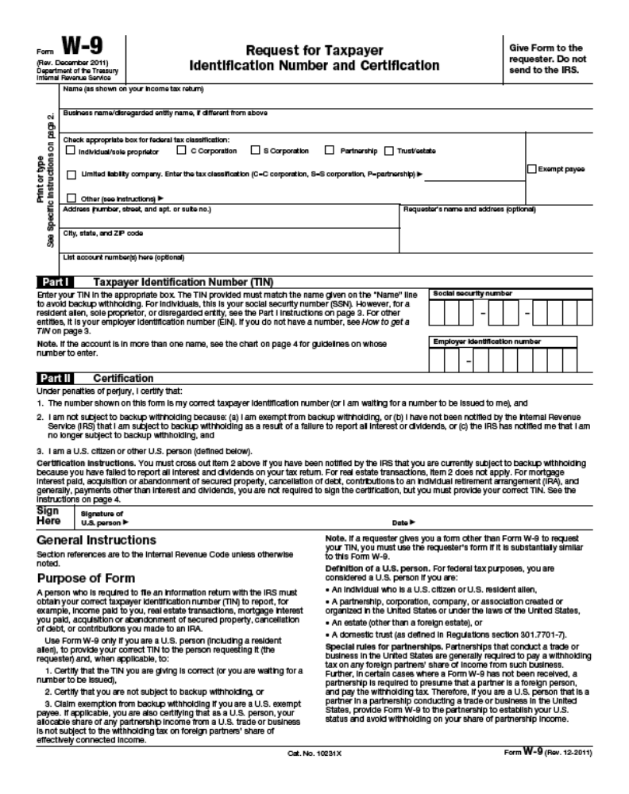
FORM E (page 2)

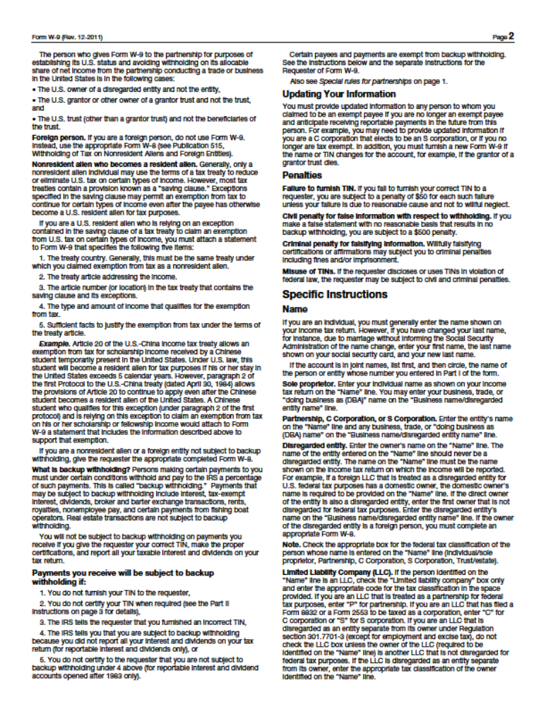

FORM E (page 3)

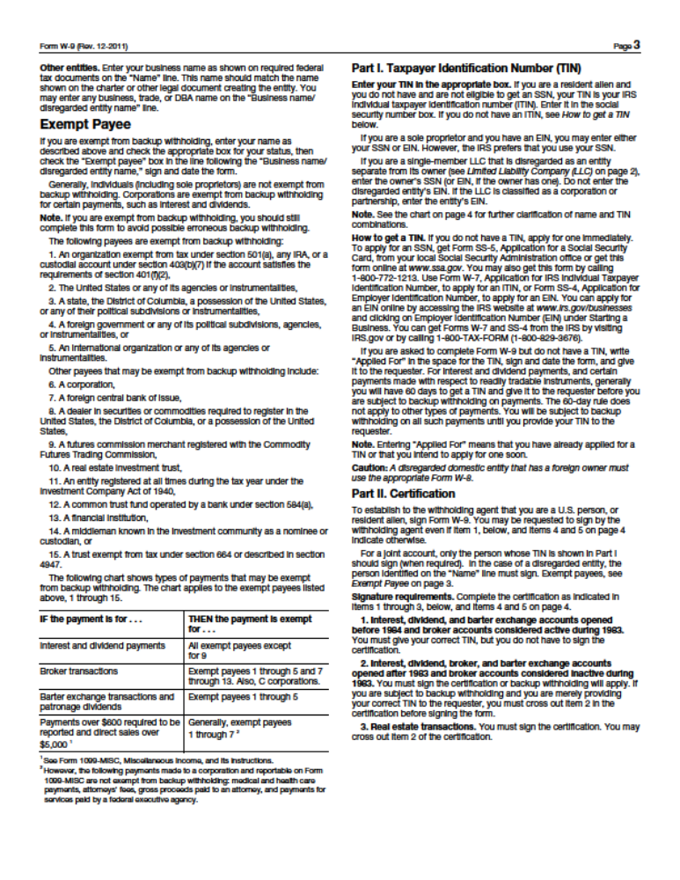

FORM E (page 4)
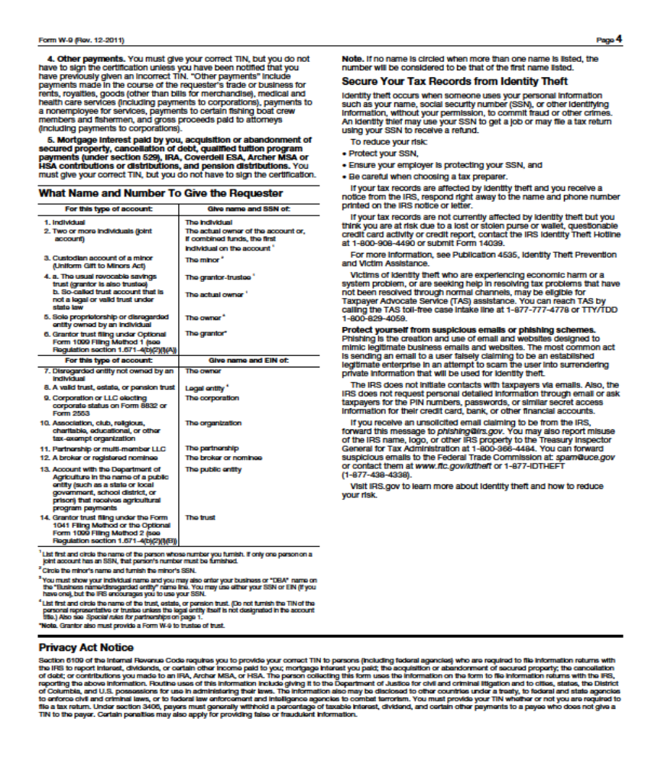
FORM F

DEVIATION/COMPLIANCE FORM

COMPANY NAME

ADDRESS CITY STATE

PHONE NUMBER FAX NUMBER

If the undersigned bidder intends to deviate from the General Conditions Standard Terms and Conditions or Item Specifications listed in this bid invitation, all such deviations must be listed on this page, with complete and detailed conditions and information included or attached. The District will consider any deviations in its bid award decisions, and the District reserves the right to accept or reject any bid based upon any deviations indicated below or in any attachments or inclusions.

In the absence of any deviation entry on this form, the bidder assures the District of their full compliance with the Standard Terms and Conditions, Item Specifications, and all other information contained in this Bid Invitation.

No Deviation

Yes Deviations

If yes is checked, please list below.

FORM G

NO BID NOTIFICATION

VENDOR NAME AGENT’S NAME

ADDRESS BID NUMBER

DESCRIPTION

The San Angelo Independent School District is interested in receiving competitive pricing on all items bid. We also desire to keep your firm as a bidder and supplier of materials and equipment. Therefore, it is important for us to determine why you are not bidding on this item. We will analyze your input carefully and try to determine if future changes are needed in our specifications and/or procedures.

I did not bid for the following reason: (PLEASE CHECK ONE OF THE LISTED REASONS)

Do not supply the requested product

Quantities offered are too small or too large to be supplied by my company.
(please circle one of the underlined)

Specifications are “too tight” or written around a particular product.
(Please elaborate on this item)

Cannot bid against manufacturer or jobber on this item.
(please circle one of the underlined)

Time frame for bidding was too short for my organization.

Not awarded a contract by SAISD when you felt you were low bidder.

Other…

Please indicate your choice for remaining on San Angelo ISD’s bid list.

I wish to remain on bid list. I do not wish to remain on bid list.

VENDOR’S SIGNATURE DATE

FORMS CHECKLIST

Completed – Non Collusion Statement - Form A

Completed – Felony Conviction Notice - Form B

Completed – Bidders Certification – Form C

Completed – Debarment and Suspension Certification – Form D

Completed – W-9 – Request for Taxpayer Identification Number – Form E

Completed – Deviation/Compliance – Form F

or

No Bid Notification – Form G

